Host a House Party to Help Afghan Women!

Organize a private screening of "View From a Grain of Sand"
"searing, wide-reaching..." - Los Angeles Times

The Revolutionary Association of the Women of Afghanistan (RAWA) have spent the past 30 years struggling non-violently for women's rights. Now, a new documentary by film maker Meena Nanji, View From a Grain of Sand, chronicles the lives of 3 Afghan women, one of them a member of RAWA.
You can do your part to help RAWA by raising crucial funds for this remarkable organization by organizing a house party. Your efforts will help sustain RAWA's life-saving projects.
What: Movie screening of View From a Grain of Sand
Where: your house or a friend's house
When: Any time
6 easy steps to planning your inspiring and informative party:
- Download the complete house party kit from www.afghanwomensmission.org
- Order a DVD of View From a Grain of Sand from www.viewgrainofsand.com.
- Pick a date and location to host your party. (TIP: Make it a potluck! Have everyone bring a dish to share and save yourself some effort).
- Drop us an email at info@afghanwomensmission.org to help us keep track of all the events
- Invite your friends, neighbors, and local activist groups. (TIP: Send out free invitations online using Evite.com)
- Using this house party kit, print up flyers and collect pledges and donations from your guests after viewing the film. Mail in pledges and donations to SEE/AWM, 22231 Mulholland Hwy, Ste 209, Calabasas, CA 91302
Houseparty Kit

Contents (make enough copies of the following flyers 1-4 for all your guests):
- RAWA Informational Flyer
- "Where Does Your Donation Go?" Flyer
- Monthly Pledge Program Signup Form
- Guest Sign-in Sheet
- Host Checklist

How to Use This House Party Kit

Order the DVD from film’s website: Click on the Contact Us/Buy a DVD button on the top menu. Allow 3-4 weeks to get the DVD.

Copy materials: On the day of your house party, have copies of all the above flyers and forms available. Make sure there are enough forms for each of your guests.

Gather pledges and donations: After screening the film, pass out the Monthly Pledge Program Signup forms and encourage your guests to fill them out right away (if you wait, people will leave without filling them out, or will forget). Make sure they return the filled out forms to you rather than take them home. If people do not want to sign up for the pledge program, encourage them to make a one-time donation (cash, check made out to SEE/Afghan Women's Mission, or credit card donation using the one-time donation option on the signup form).

Have a discussion about the film: What did people think of the three women? Does the US bear responsibility for Afghan women losing their rights? What should the US do now? How can people help RAWA in their struggle? Encourage guests to order the film: Most of your guests will be truly moved after watching the film. Pass out order forms for the film if they want to throw their own house party or for private viewing.

Signup guests to stay in touch: Pass around our Guest Sign-in sheet if people want to stay connected to this issue. Afghan Women's Mission has an extremely low traffic list (1-2 emails per month) with an easy unsubscription option. We never share email addresses with any other organization.

Mail in Donations and Sign-in sheet: Soon after your party is over, mail in the checks, cash, any completed pledge forms, and guest sign-in sheets to Afghan Women's Mission at PO Box 40846, Pasadena, CA 91114, USA. Do not wait too long as checks and credit card donations need to be processed in a timely fashion.

Report back to AWM: Send photos of your event, as well as a description and/or testimonies from your guests to info@afghanwomensmission.org. We will post it to our
website in order to encourage others to do the same.

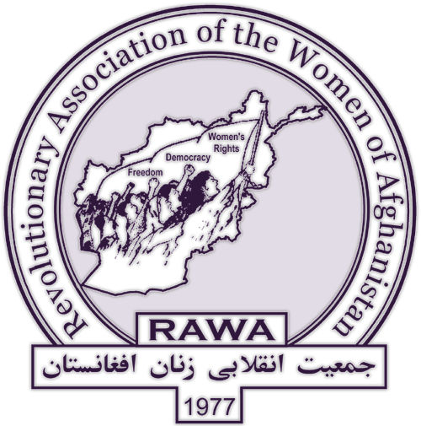
RAWA needs your support and solidarity

The Revolutionary Association of the Women of Afghanistan is an organization of Afghan women fighting against imperialist wars and religious fundamentalism since 1977. Their activism is based solely on secular democracy, women’s rights, and human rights. RAWA is a non-violent, underground organization. Learn more at www.rawa.org.

With all my strength I’m with you on the path of my land’s liberation.
My voice has mingled with thousands of arisen women
My fists are clenched with the fists of thousands compatriots …
I’m the woman who has awoken
I’ve found my path and will never return.

-- Excerpt from the poem, I’ll Never Return, by Meena (1956-1987), RAWA’s martyred founder.

RAWA’s activities are two-fold: humanitarian and political. They run scores of schools and orphanages (for girls and boys), literacy courses and income generation projects for adult women, health clinics, mid-wife courses, and emergency relief programs for refugees. They also organize public demonstrations, publish a quarterly political magazine (“Payam-e-Zan”), document human rights abuses, and author statements on current events.

"RAWA [is] the extraordinary women's movement that is as doggedly committed to democracy as it is to dreaming of another, better world."
– Arundhati Roy

SUPPORT RAWA:
You can help fund RAWA’s activities by making a tax-deductible contribution to “SEE/Afghan Women’s Mission.” Mail checks to SEE/AWM, 22231 Mulholland Hwy, Ste 209, Calabasas, CA 91302. Visit www.afghanwomensmission.org for more information.

BOOKS ABOUT RAWA:

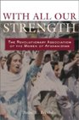
With All Our
Strength:
The Revolutionary
Association of the
Women of
Afghanistan by Anne Brodsky
By Anne Brodsky

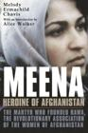
Meena - Heroine
of Afghanistan
The Martyr
who founded RAWA by
Melody Ermachild Chavis

WHERE DOES YOUR DONATION GO?

- Your donation to Afghan Women’s Mission (AWM) goes directly towards the projects of the Afghan women’s group, RAWA.
- Our overhead expenses are only 6.5%, which is lower than most non-profit organizations.
- Each project is budgeted before money is spent, and documented via photographs, video, and testimonies, after the project is completed.
- AWM volunteers occasionally visit Afghanistan to document firsthand RAWA’s projects.
- All donations are tax-deductible to the extent of the law

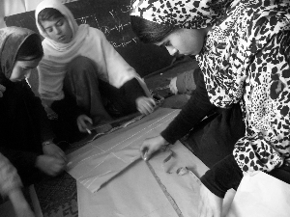

KABUL, Afghanistan -- Women and girls in one of RAWA’s “income generation” projects, learn how to sew and embroider clothes.

About RAWA
In 1977, a young Kabul University student named Meena, founded the Revolutionary Association of the Women of Afghanistan (RAWA) to struggle for women’s freedom in a conservative country. After the 1979 Soviet invasion, RAWA expanded their mandate to fight against fundamentalist misogyny and foreign domination. For three decades they have empowered Afghan women through humanitarian aid and political agitation. After Meena’s brutal assassination in 1987, RAWA continued their work underground and today are on the forefront of the women’s rights movements. Their projects include schools and orphanages for boys and girls, literacy courses for adult women, health clinics, the publication of their political magazine, Payam-e-Zan, documentation of human rights abuses, and public demonstrations. RAWA is a non-sectarian, non-violent organization advocating secular democracy, women’s rights, and human rights in Afghanistan. For more information, visit www.rawa.org.

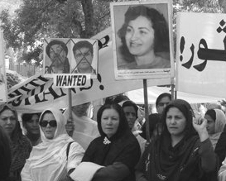

ISLAMABAD, Pakistan – Carrying images of Meena, Afghan women march at a RAWA demonstration against fundamentalism and war in their nation.

About AWM
In summer 2000, a small group of Americans in Southern California helped organize the first US tour by RAWA members. We were so moved by their courage and dedication, that we started an organization, Afghan Women’s Mission (AWM) to financially support RAWA’s work through US donations.

AWM is a project of the Social and Environmental Entrepreneurs (SEE), a registered non-profit organization. For a fee of 6.5%, SEE staff members process all donations and disbursements and oversee our operations. SEE’s tax identification number is 95-4116679. For more information about SEE, visit www.saveourplanet.org.

AWM is entirely run by volunteers who are dedicated to working in solidarity with Afghan women. We collect donations, arrange speaking tours for RAWA members, organize local fundraisers, sell Afghan crafts from RAWA’s sewing classes, and keep Americans informed of what is happening in Afghanistan. Our work is based on the underlying assumption that Afghan women are perfectly capable of organizing themselves and rebuilding their nation – what they need from Americans most is financial and moral support of their work. For more information, visit www.afghanwomensmission.org.
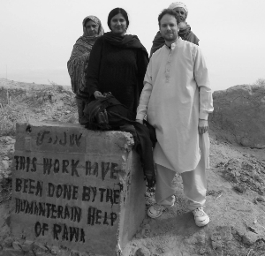

FARAH, Afghanistan -- AWM Co-Directors, Sonali Kolhatkar and James Ingalls visit Afghanistan in 2005 to document RAWA’s projects.

HOW TO MAKE A DONATION Make checks payable to “SEE/Afghan Women’s Mission,” and mail them to SEE/AWM, 22231 Mulholland Hwy, Ste 209, Calabasas, CA 91302 OR, make a secure online credit-card donation at www.afghanwomensmission.org

Make a Monthly Commitment to Afghan Women

Afghan Women and Girls Are Still Struggling for their Rights …

- A young woman named Amina was recently stoned to death by a decree from a local mullah.
- Hundreds of young women continue to commit suicide by self-immolation in Herat.
- Women in Nangahar province were banned from appearing on television or radio.
- President Karzai has welcomed Northern Alliance and “moderate” Taliban members to form a new government. Both the NA and Taliban have anti-woman policies.
- 28 year old member of Parliament, Malalai Joya has survived four assassination attempts and was recently kicked out of Parliament for denouncing fundamentalist warlords.

When the world’s attention was drawn to Afghanistan on September 11th 2001, thousands of people gave generously to fund RAWA’s* life saving programs for Afghan women and girls. But the media spotlight has left Afghanistan and donations are steadily decreasing. RAWA has been forced to shut down many crucial projects. Your monthly pledge would allow RAWA to pursue their work in the face of continuing adversity. Please join our Monthly Donor Program today to help us continue our programs for Afghan women and girls.

* The Revolutionary Association of the Women of Afghanistan (RAWA) is a women’s humanitarian and political organization whose projects we fund. For more information, please visit http://www.rawa.org.
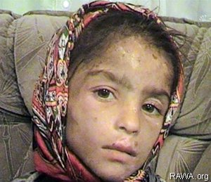
7 year old Samia, a survivor of on-going violence against women and girls in post-Taliban Afghanistan .
Photo courtesy; www.rawa.org

JOIN US …

Where Does Your Donation Go?

- $150 a month pays the salary of a doctor
- $80 a month pays the salary of a nurse
- $45 a month pays the salary of a school teacher
- $25 a month pays for books and supplies for 10 students
- $10 a month pays for a mother and child to visit the doctor

For more information or to make an online contribution, please visit www.afghanwomensmission.org.
Tel; 626-676-7884
Email: info@afghanwomensmission.org.

------------------------------------------------------------------------------------------------------------------------------

◻ Yes! Please enroll me in the Monthly Pledge Program.
◻ I would like to make a one-time donation.

Your donation is tax-deductible to the fullest extent of the law.

DONOR INFORMATION P l e a s e P r i n t C l e a r l y

Name (first, m.i., last) ____________________________________

Street address___________________________________________

City_______________________ State _______ Zip____________

Email Address ___________________________________________

Telephone ______________________________________________

AMOUNT OF DONATION
◻$10 ◻$25 ◻$45 ◻$80 ◻$150 ◻$1000 ◻Other $_____

Please fill out this form and mail it to: SEE/AWM, 22231 Mulholland Hwy, Ste 209, Calabasas, CA 91302

CHECKS
Please make checks payable to: "SEE/Afghan Women's Mission" and mail directly to us at the above address

CREDIT CARD DONATION
◻ Visa ◻ Mastercard ◻ Discover

Credit Card Number: __ __ __ __ __ __ __ __ __ __ __ __ __ __ __ __

Exp. Date: ___/___ ◻ check here if billing address is same as mailing address

Street address_____________________________________________

City______________________ State _______ Zip______________

Signature: ___________________________ Date: _____________

Event Name: ___________________
Location: ___________________
Date: ___________________

Afghan Women’s Mission
A Project of SEE

P L E A S E P R I N T C L E A R L Y

NAME | ADDRESS | PHONE | EMAIL
How to Use This House Party Kit
Order the DVD: Place an online order for the DVD of View From a Grain of Sand at www.viewgrainofsand.com. Allow at least 3-4 weeks to receive the DVD.
Copy materials: On the day of your house party, have copies of all the above flyers and forms available. Make sure there are enough forms for each of your guests.
Gather pledges and donations: After screening the film, pass out the Monthly Pledge Program Signup forms and encourage your guests to fill them out right away (if you wait, people will leave without filling them out, or will forget). Make sure they return the filled out forms to you rather than take them home. If people do not want to sign up for the pledge program, encourage them to make a one-time donation (cash, check made out to SEE/Afghan Women's Mission, or credit card donation using the one-time donation option on the signup form).
Have a discussion about the film: What did people think of the three women? Does the US bear responsibility for Afghan women losing their rights? What should the US do now? How can people help RAWA in their struggle? Encourage guests to order the film: Most of your guests will be truly moved after watching the film. Pass out order forms for the film if they want to throw their own house party or for private viewing.
Signup guests to stay in touch: Pass around our Guest Sign-in sheet if people want to stay connected to this issue. Afghan Women's Mission has an extremely low traffic list (1-2 emails per month) with an easy unsubscription option. We never share email addresses with any other organization.
Mail in Donations and Sign-in sheet: Soon after your party is over, mail in the checks, cash, any completed pledge forms, and guest sign-in sheets to Afghan Women's Mission at SEE/AWM, 22231 Mulholland Hwy, Ste 209, Calabasas, CA 91302. Do not wait too long as checks and credit card donations need to be processed in a timely fashion.
Report back to AWM: Send photos of your event, as well as a description and/or testimonies from your guests to info@afghanwomensmission.org. We will post it to our website in order to encourage others to do the same.

Host’s House Party Check List – print this sheet to help organize your event

3-4 Weeks Before Party:

- Secure location for your party
- Order DVD copy of View From a Grain of Sand from www.viewgrainofsand.com
- Send out invitations to friends, family, colleagues and neighbors.

2 Weeks Before Party:

- If you are serving food and drinks, plan your menu OR if it is a potluck, coordinate the menu items with your guests.

1 Week Before Party:

- Make sure the DVD has arrived.
- Test the DVD on your DVD player.
- Make follow up calls or send emails to guests, reminding them to RSVP if they haven’t already done so
- Download all the flyers from the House Party Kit and make enough copies for all guests.
- Email info@afghanwomensmission.org to let us know you’re organizing a house party.

Day Before Party:

- Purchase drinks, flowers, etc.
- Confirm menu

Day of Party:

- Welcome guests and briefly tell them why you have organized the party.
- Serve drinks, distribute flyers and get ready to watch the film.
- Set aside 80 minutes to watch the film.
- Have a discussion about the film and urge guests to sign up for the monthly pledge program or make one-time donations. TIP: Despite their best intentions, most people will not give money unless directly asked, so don’t be shy!
- Pass around the sign-up sheet for people to sign up for our mailing list. Remind them that it is a private, very low-traffic list, with no more than 1-3 emails a month.
- Serve food and continue discussion.
- Thank your guests before they leave

Day After Party:

- Add up all donations and write them down on a sheet of paper and keep a copy for yourself.
- Enclose this sheet along with the donations, monthly pledge forms, and sign up sheets in an envelope and mail it to: SEE/AWM, 22231 Mulholland Hwy, Ste 209, Calabasas, CA 91302. To prevent mail theft, please consider sending registered mail or Fed Ex.

2 Weeks After the Party:

- Email info@afghanwomensmission.org to make sure we have received the donations.

